MAPLE SYRUP PRODUCTION Jean-Pierre Hickey

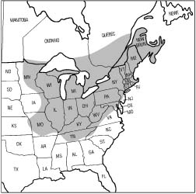
Hard winters, mild springs, hot summers, are defining weather characteristics of most of the north-eastern American continent. Although this pattern can be tedious and very enjoying it has some great advantages. Maple syrup is one of these advantages. For years maple syrup has been a privileged product of the province of Quebec, exported thru out the world. Oddly enough, it is one of the few agricultural products whose origin comes not from the European settlers but from the Native Americans. This paper will briefly analyse the main steps in maple syrup production combined with an overview of it‘s history. Furthermore, it will analyse current production methods with emphasis on collecting, transport, storage and evaporation of sap, as well as packaging and grading of the final product. A chapter also analyses the energy saving methods used in present day industry.

Maple syrup production methods have not changed for centuries. The basic methods of production have stayed the same: first collect the sap and boiling of the excess water, hence concentrating the sugars and making syrup (and other maple products).

PRODUCTION METHODS

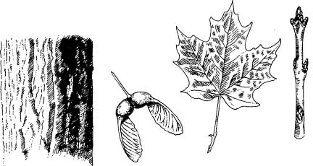
The first step in all production line of maple syrup is the tapping and collection of maple sap. But to fully understand this process, it is necessary to take a closer look into the physical changes that occur in the maple tree to produce this great delicacy. It is a wrong assumption that any maple tree is adequate for the production of syrup. Most commercial sugar-bushes (term used for maple tree farm) tap the abundance of sugar maples (Acer saccharum) and black maples (Acer nigrum) on their land (red maple (Acer rubrum) is also tapped but to a much lesser extent). These trees have are preferred because of their greater sugar content and there life span of up to 200 years. During the spring months, from March to Mai, the changes in temperature from freezing at night, to maybe +5 to +10 in the day, causes the maple sap to raise and fall in the tree. At the beginning of this process, usually during March, the owner of the sugar-bush taps his trees. This process consists of drilling a whole of 7/16 inch (1,5 cm) diameter and 3 inches (7.5 cm) deep into the side of all healthy maple on the farm and inserting a spout to which is attached a collecting pan. Hence, the sap flow get redirected into the collecting pan because of the high internal pressure of the tree and can be collected. The method of collecting the sap in pans is now only used in small maple sugar production because the sap must be collected by hand and brought back to be processed. This is a very labourious operation especially if the sugar-bush is situated in a hilly area. Since the middle of 1940 a piping system has been developed to transfer the sap directly from the tree to the processing line. This allows a quicker storage (sap should not stay in a bucket more than a few hours) , cleaner sap (no debris from the tree etc.) and a much easier collection. But, on the downside, it is quite expensive. Almost all big sugar-bushes in Quebec and North-Eastern USA use this system to collect the sap for processing. Traditionally, gravity alone was used to bring the sap into storage but in the 60’s a vacuum pump was introduced which allows faster transport as well as greater yield in the production without significantly changing the chemical composition of the sap. But this newer method requires a more complex and expensive set up for the pump as well as the air tight plastic tubing.
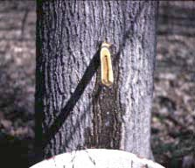
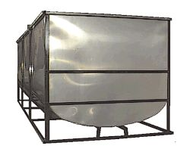
Once the sap has been tapped, it must be stored. The storage is critical in the production line of maple syrup since a long storage will directly impact on the quality of the finished product. Usually the tapped sap is carried into these big vessels similar to the ones used in the dairy industry. Generally they have a 500 to 1000 gallon capacity. The sugarhouse should have a separate room for the storage tank since the degradation of the sap is closely linked to the storage temperature. Therefore, storing the sap in the same room as the evaporator will have bad consequences on the final quality. Before the storage of the sap, many methods are used to lengthen the storage time. Among the most used is ultraviolet light treatment and filtering. The ultra-violet light treatment helps to reduce the number of microrganisms present in the sap, especially in the later part of the sugar season. The filtering of the sap also is used to reduce the living organism content of the sap, that range in size from hundreds of microns to less than a micron, and multiply very rapidly. This process is usually done right before entering the storage tanks.

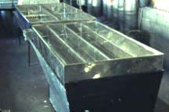
The maple syrup production consists of evaporating the water contained in the sap to obtain a higher concentration of sugars as well as changing the chemical composition of the sap in order to have a distinct colour and taste. The evaporator is has undergone massive changes in design over the past hundred of years passing from a fire to oil, steam and finally to gas. The modern evaporators consist of 2 pans: the sap pan and the syrup pan. The sap pan, often referred to as the flue pan and normally the rear pan, is composed of deep and narrow channels to increase the heat transfer to the sap. Afterwards, the heated and somewhat evaporated sap passes thru a semi rigid pipe to the syrup pan, often called the front pan, and is normally located over the firebox. This last pan is flat hence, having a big evaporating surface. These evaporators work in a continuous (or sometimes batch production at the beginning and end of the season) fashion with the sap flowing continuously into the flue pan and after the into the syrup pan. It is important to keep the depth of the syrup pan constant to avoid burning of the sugars of poor quality of the syrup. A conventional 2 pan evaporator of 6‘ x 14‘ can evaporate 310 gallons of water per hour. During this process it is important to monitor the syrup for the desired consistency and flavour. The longer the syrup is evaporated in the syrup pan the thicker and darker it gets. Ideally, producers try to obtain a light colored syrup with a very high sugar content. To do so, it is essential to minimize the boiling time, assure a correct temperature, depth and heat distribution. This last part is the art of maple syrup producing. Generally, one liter of normal density maple syrup requires approximately 42 liters of water to be evaporated during this process. Therefore we need a great quantity of sap to be collected to have a profitable operation.
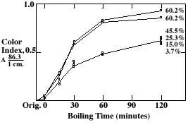

This following diagram shows an overview of the whole process:
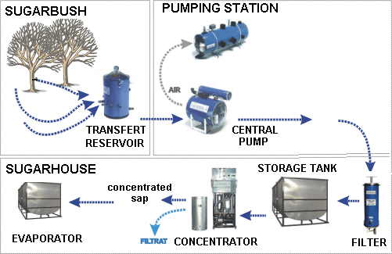

ENERGY SAVING METHODS USED IN INDUSTRY
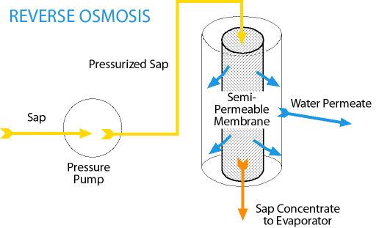
There are many ways maple syrup producers save energy, hence money, in the evaporation process we will discuss the most commun methods used these days. Reverse osmosis is probably the most used by the bigger producers. This method consist of removing, physically, the water from the sap before passing it thru the evaporator, saving much energy in heating the excess water to be boiled off. Reverse osmisis is achieved by forcing the sap thru a filter whose pores are big enough to let the water molecules pass but too small for the sugar and other organic materials in the sap. This process can be repeated numerous until the sap has a high sugar content. Usually we are able to remove up to 75% of the water, therby saving much fuel in the heating process.
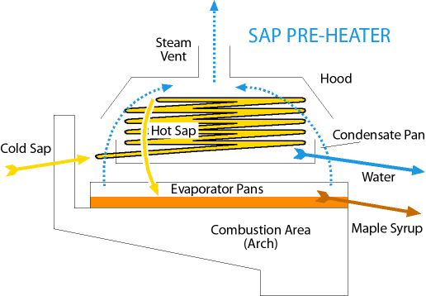
Another method which can be used in conjunction with reverse osmosis consists of preheating. Using the excess generated heat in the final stage of the evaporator to preheat the incoming sap. This method can save up to 15% of total fuel cost for a sugarbush producer and is quite simple to put into practise.

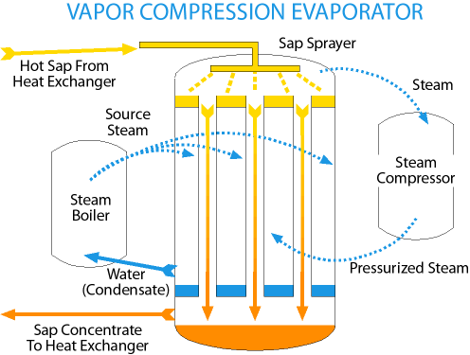
A much newer method consists of vapour compression technic similar to the one used for the desalinasation of salt water. In the vapor compression process the water in maple sap is evaporated, but unlike open pan evaporators, the heat energy in the steam produced from the evaporating sap is captured and repeatedly reused. Evaporation takes place in an evaporation chamber in which hot sap is sprayed onto an even hotter surface. The result is a vaporization of some of the water molecules which are then pulled out of the evaporation chamber under negative pressure. This vapor is compressed, raising its temperature, and is reused to reheat the evaporating surface. Sap is recycled until the desired density is achieved. To increase efficiency, sap is preheated with heat exchangers which absorb heat from the evaporation chamber and finished syrup. External heat energy is required to start the evaporating process but only intermittently thereafter to maintain it.

FINAL FILTRATION AND PACKING
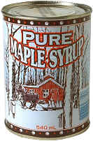
After evaporation, the syrup contains suspended solids which gives a cloudy texture to the syrup. For commercial purposes, it is important to remove these undesired solids and prevent sedimentation in the bottom of the syrup during packaging and storage. Most producers use either sedimention or filtration to purify the syrup. Traditionnally, sedimentation was mostly used but recently most producers have opted for filtration instead. Sedimentation consist of leaving the syrup motionless in a container for a few days up to a week and afterwards carefully removing the clear syrop from the top. But this method requires reheating upto 85°C before packing to ensure sterilization which darkens the syrup and reduces the grade. Filtration, especially pressure filtration, is used by the bigger producers. The syrup is passed straight from the evaporator thru the plate filters under a lot of pressure and can be packed immediatly. The packing methods are usually very conventionnal in the food industry. For the greatest results, most producers can their product in 500ml metallic containers but glass containers are also used but mostly for export and tourist gifts. The glass allows light to pass thru the syrup and affects the quality if it is left exposed to light for a long time.

GRADING OF SYRUP
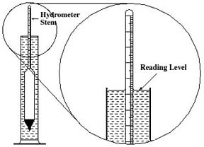
Maple syrup is classified according to the grade which is determined by the colour but most meet a minimal density requirement. Usually the colour of the maple syrop is calculated using a light transmission percentage (see table on next page). As for the density, it is usually calculated either by light refractomer or hydrometer(as shown) and is mesured using the Brix density scale or less frequently the Baumé scale. Producers will generally try to obtain a lighter syrup hence, obtaining more syrup per gallon of sap. To do this, they will often combine the darker syrop with either distillated water or ligh syrop to obtain the desired grade to be sold or exported. Another common practise is to mix batches in order to have a more uniform quality thru out the whole sugar season. There is often differences between the quality of the syrup at different times during the season therefore the mixing uniforms the quality and taste.
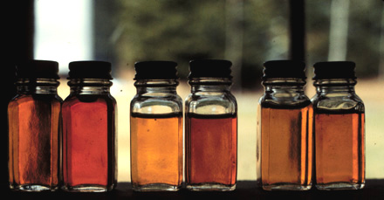

Maple Syrup Grade Designation Based on Percent of Light Transmittance
% Light  Transmittance¹ | Canada  Federal & Quebec
Not less than 75%Tc | No. 1 Extra Light
Between 60.5 & 74.9%Tc | No. 1 LightGrade A
Between 44.0 & 60.4%Tc | No. 1 MediumGrade A
Between 27.0 & 43.9%Tc | No. 2 Amber
Less than 27%Tc | No. 3 Dark

CONCLUSION

Maple syrup production has suffered many changes thru-out the years without modifying greatly the original process. It has conserved its importance in the economy of much of north-eastern America. Because of its high requirements in specific weather patterns very few places in the world produce such a product. That is why the province of Québec alone produces nearly half of the worlds production. It has been only recently has this liquid gold has been exported to such an extent. Currently, the main foreign market outside North-America is Europe (especially France) as well as Japan. The current production methods allow a great output per season hence fulfilling the sweet tooth of much of quebecers as well as the world.
