Tawny Albrecht
Peanut Butter Processing Line
Due: 5-28-03
Peanut butter is a spreadable food that, if enjoyed as much as I do, can go on just about anything your heart desires. Peanuts are rich in vitamins and minerals including potassium, phosphorous, magnesium, iron and zinc. They also contain about 28% protein, 48% fat, and provide extended energy because of how slowly the energy is released from the fat. Peanut butter originated from South America 1000 years ago, where an edible paste was created from peanuts, but peanuts are now also grown in other warm climates such as Australia, China, India, West Africa and the USA (in Georgia, Texas and Oklahoma). A more advanced form of peanut butter was made in the USA a little over 100 years ago. A person can choose from a smooth or cruchy style of peanut butter, and with or without added salt or sugar.

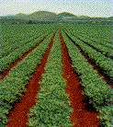
The Peanut Process
Peanuts are planted after the last frost in Apríl, when the soil temperatures reach from 65 to 70 degrees Fahrenheit. Specially grown and treated peanut kernels from the previous year’s crop are planted two inches deep, about one to two inches apart in rows. Peanut seeds break the soil about ten days after planting and grow into a green oval-leafed plant about 18 inches tall. The peanut plant is different because it flowers above the ground (yellow flowers form about 40 days after planting), but fruits (or forms) below the ground. The flowers pollinate themselves, then the petals fall off as the peanut ovary begins to form. The ovary grows away from the plant on the vine and saturates the soil. Peanuts are harvested quickly 120 to 160 days after planting, usually in September or October. When the soil is not too wet or dry (so the plants don’t stick in the ground), the farmer drives a tractor that loosens the plant from four to six inches under the ground with a blade, cuts the tap root with the blade and lifts the plant from the ground with a shaker. Then the plant is laid upside-down in windrows (like ridges) to dry in the sun for two or three days. Next, the farmer drives a combine over the windrows to pick the peanuts from the vines and collect them in a hopper.
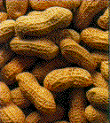
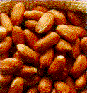
Peanuts go from the harvest to plants that are located near the growing fields. These plants remove the shells, clean the nuts and pack them into bags, which will hold more than 2000 pounds of peaunuts, for shipment to the peanut butter plant. Here, the bags are unloaded into bucket conveyors that move the nuts from one processing step to the next. The first step is to remove all impurities, such as stones, soil, stems and sticks from the peanut plants, from the stream line. Gravity separators do this by sorting out objects that are lighter or heavier than peanuts. The peanuts then go to a continuous roaster to be slowly carried through on a belt with circulating hot air, for about 20 minutes. If not roasted evenly, the peanuts‘ flavor and color could be flawed. By changing the air temperature, belt speed or peanut layer thickness on the belt, the peanuts are roasted properly. Next, the peanuts are cooled quickly, to stop the cooking process, retain an even color and prevent the loss of too much oil, then taken by a conveyor belt to the blanching machines that remove the skins. This prevents the peanuts from having dark spots from the skins. The peanuts are either brushed with burly bristles or rolled against rubber rollers. Finally, the peanuts need to be inspected for quality. The nuts are conveyed through an electronic color sorter that removes under or over roasted nuts. They also go by a trained inspector who looks them over to pick out any that do not look right.

The Peanut Butter Process
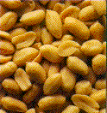
The peanuts are now conveyed to the grinders, which are like giant milkshake machines. If chunky peanut butter is wanted, some of the nuts are taken to a chopper to be added into the peanut butter before filling the jars. The peanuts are ground in two stages because one long grinding would produce too much heat and ruin the flavor of the peanut butter. In the first stage, the peanuts are ground alone. In the second stage, less than 10% of other ingredients (because peanut butter has to be made from a minimum of 90% peanuts), such as salt, sweetener and stabilizer are added. This stabilizer, a special vegetable oil, keeps the peanut oil from separating out to the top of the jar. Next, the peanut butter is pumped through a metal detector to make sure that no metal got in it during the grinding. Then it is pumped into a deaerator, which removes trapped air. Finally, the hot peanut butter (from grinding) passes through a heat exchange to cool it down to between 35 and 50 degrees Celsius so that it can be put into containers on the filling line. The filling machine is carefully timed to put the correct amount of peanut butter in each jar.

The Final Process
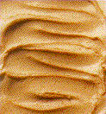
Next, the jar is conveyed to the capping machine, and then sent through an induction sealer, which seals the inner liner to the top of the jar. Afterwards, another machine applies the label to the jar. An inspector then packs the jars into the shipping case so that he/she can make sure each label is on straight and the jar looks okay. Finally, the cases are glued shut and the peanut butter sits in the warehouse to wait a couple days before shipping. This is to test the peanut butter for mold or bacteria that could have gotten into the peanut butter. At the company Sanitarium, the whole process, from roasting to sealing the jar, takes only about three hours.
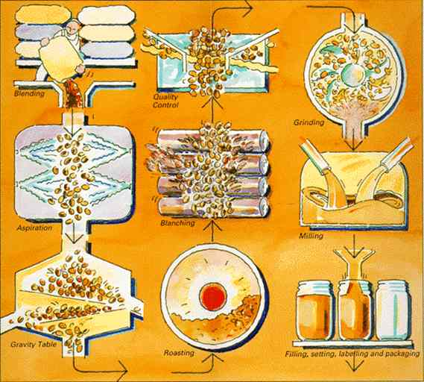

Machine plants to produce peanut butter.
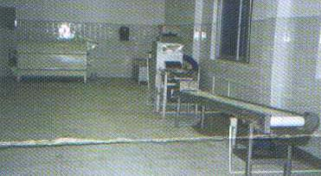
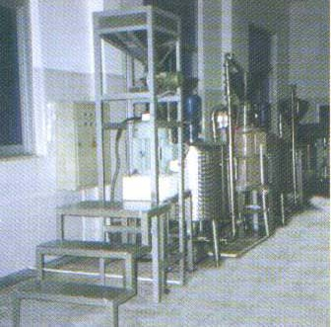
The John B. Sanfilippo & Son, Inc. has facilities in Bainbridge and Garysburg.
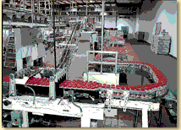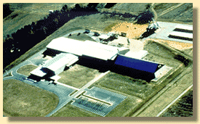
Bainbridge, Georgia has 245,000 square feet of space and one of the fastest jar lines in the industry. It also is the only facility in the US where peanuts are shelled, blanched, roasted and jarred in one continuous process. This plant has a processing capacity of over 120 million pounds of peanuts yearly. Garysburg, North Carolina has 120,000 square feet of space and can shell and process 70 million pounds of Virginia type peanuts yearly.

