ROQUEFORT

Introduction

Roquefort (blue cheese) looks probably disgusting for you. But if you were French you would be fond of this very delicious cheese, which is as good cooked in a recipe as just eaten with a slide of bread.
Please let me tell you how this symbol of my country is made…

- The Legend

A long time ago, a shepherd from Roquefort was eating in a cold cave when he saw a very beautiful girl leaning against a tree on the top of a hill. He decided to follow her, leaving thus both his herd and his meal, made of bread and ewe curd. A few days later, back to the cave he found his bread and curd covered with mould. As he was starving he still decided to finish his meal, and was very surprised to find it delicious!
Roquefort was born

- The milk collection

The milk collection is a much more important step than what you could expect. The milk used to make Roquefort must indeed satisfy to quite a few conditions:

  - First of all it must come from an ewe herd born and bred in Aveyron, otherwise you are not allowed to call the cheese thus obtained Roquefort. Moreover the one who wants to make Roquefort must use milk from one and only one race of ewe: Lacaune‘s ewe.

  - The ewes must be bred in mountain between 2100 and 3500 feet above the sea level. There you find actually the best pastures, which is nothing but a small detail.

  - The milk must be collected twice a day, only from November to June.

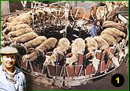
The milk collection

All this conditions can sound stupid, but it is actually a good way to be sure that the milk, and afterwards the cheese, thus obtained are from the best quality. Controls are frequently made to make sure that nobody tries to cheat.
In such conditions an ewe can produce on average 2.5 litres of milk per day, allowing thus to make 45 kilos of Roquefort per year.
Once collected, the milk is transported within a few hours to the cheese manufacturing plant, where it is gathered in huge vessels.

- The milk pasteurisation

This step of the manufacturing process is nowadays a obligation, because of a Brussels‘ European Parliament decision. But only a few years ago it wasn’t necessary to pasteurise the milk used to make Roquefort.
The process is very simple : the milk temperature is raised until 140°C (284°F), then lowed within a second until 70°C (158°F). Thus the bacteria needed for further steps can survive, while the harm bacteria are killed.
The milk temperature is then gradually lowed until the air temperature.

- The curdling

If you forget a bottle of milk in you refrigerator the milk starts to curdle within a few days. What is, in such case, a very bad experience for you if you try then to taste the milk, is an unavoidable step of making of cheese.
Within a few days the bacteria that are still alive in the milk start to multiply. The result is that the milk acidity raise faster and faster, until the milk proteins (casein) start to coagulate.
Nowadays, as it is previously pasteurised, it is necessary to add harmless bacteria (called pressure) to the milk, so that the curdling doesn’t take too much time. This bacteria are bred in laboratories. Thanks to them the milk curdles within two days. It is however important to maintain a temperature between 18 and 20°C (65°F) in the room.
Once the milk has curdled (left picture) it is already solid enough to be divided into small cubes (right picture), which is going to make the next step easier

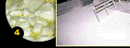
Curdled milk

- The ensemencage - inoculation

This step allows the curdled milk to turn into Roquefort. The curdled milk is mixed with penicillium roqueforti, an harmless bacteria extracted from rye bread, which is a traditional bread typical from southern France, especially Aveyron.

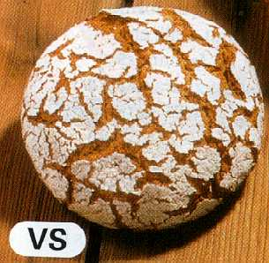
Rye bread

The bacteria are extracted from this bread in laboratories. The process is very simple:

- Rye bread is bought from a local baker’s

- Once in laboratory it is stored and left in peace until a layer of mould starts to recover its surface

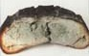
Mould has appeared

- The mould (which is actually made of penicillium roqueforti )thus obtained is then gathered by centrifugation, after the bread had been squeezed into powder, and eventually added to the curdled milk with an average amount of 4 grams of mould for 5000 litres of milk.

Once the mould has been added the milk temperature is raised until 32°C (90°F) and left in peace for 48 hours. Thus the bacteria can spread in the curdled milk. Then the next step can start.

- The draining and salting

The curdled milk is stored in small boxes whose shape is the same as the shape of the finale cheese. These boxes are indeed like strainers which allow, thanks to gravity, the evacuation of the whey. The boxes are turned upside down five times a day during five days, so that the draining is much effective. Then the salting can start.
The salting consists in spreading a layer of salt on the upper side of the cheese, leaving it for 2 days, then spreading another layer on the other side and leaving the cheese again for three more days. The salt stops the inlet spreading of the bacteria and makes the previous draining perfect. Moreover it allows the appearance of an outlet crust which allows later a good conservation of the cheese.

- The refining

This is the most famous step of the manufacturing process of Roquefort, since it lasts at least for 150 days (5 months).
First, the cheese needs to be cleaned. A thick and sticky layer appears actually during the salting : the “pégot“. This layer is not eatable and really gives a bad aspect to the cheese. It is therefore important to clean this layer of “pégot“. The machine used for doing this operation is called brusher.

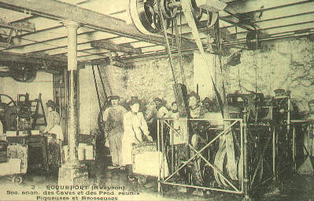
The first known automatic brusher (19th century)

The second operation consists in boring the cheese from one side to the other with 48 needles whose diameter is on average between 3 and 4 millimetres. Thus the basement’s wet air can be in contact with inside the cheese. From then the addition of moisture and bacteria inside the cheese allows the appearance and growing of mould.
But mould still needs time to grow up. Moreover the cheese paste is still too fresh to be eatable. That’s why the third operation consists in leaving the cheese in a basement between 4 and 6 months. During this while the paste changes under the biochemical action of the bacteria contained in all milk products, while the mould grows up until that large stains appear on and in the cheese.

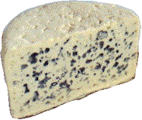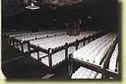
Large stains A basement

This two parameters (biochemical action + mould) give its consistency, taste and odour to the cheese.

After six months the cheese is finally ready to be eaten…. Enjoy your meal, and long live to French cuisine !

SOME RECIPES….


Filet Mignon Steaks with Roquefort

2-4 filet mignon steaks
1 tablespoon extra virgin olive oil
1 tablespoon coarse black pepper
snipped fresh sage or basil leaves
sprinkling of coarse sea salt
1/2 cup port wine
1/2 cup beef stock
1 bunch spinach or lettuce leaves, washed, dried, and torn slightly
4 oz. Roquefort (or Cabrales or Stilton) or Feta, or not at all
Brush the steaks with the olive oil and then sprinkle with the pepper, herbs, and salt. Place a large good quality heavy bottomed saute pan over high heat until very hot. Add the oil and then the steaks. Sear for about 4 minutes per side, reducing the heat as necessary. Turn meat over, and continue to sear on the other side, until cooked to your liking. Remove to a warm plate. To the hot pan, add the port and cook and stir until it has reduced by half. Stir in the broth and continue to cook and stir to reduce to a nice glaze-like consistency. Arrange the steaks on a platter and drizzle the sauce over and then quickly add the spinach to the pan and stir it around to wilt it slightly. Arrange around the steaks, and crumble the cheese over the top. Stand back for the raves and applause

Roasted garlics with Roquefort

6 |  | heads garlic
6 |  | teaspoons olive oil
3 |  | teaspoons butter
2 |  | teaspoons chopped fresh rosemary or 2sprigs fresh rosemary
2 |  | teaspoons chopped fresh basil
8 |  | ounces Roquefort cheese, crumbled
 |  | French baguette, sliced (optional)

1. | Preheat oven to 375 degrees.
2. | Cut ˝ inch from the top end (opposite root end) of each garlic head, exposing cloves.
3. | Remove any loose papery outer skin.
4. | Place garlic, cut side up, in center of a 10-inch square cut from a double thickness of heavy aluminum foil.
5. | Bring foil up around the garlic bulb to form a bowl.
6. | Sprinkle garlic with rosemary and basil over bulb and add 1 teaspoon olive oil and ˝ teaspoon butter on each bulb.
7. | Close the foil completely by twisting the tops and place in oven under medium heat or on rack of uncovered grill for 30 minutes- this may all be prepared 8 hours in advance- cover and chill.
8. | Melt Roquefort until creamy and serve by spreading cheese on the slices of bread and put garlic cloves on top with fork.

