Report on Activities and Deliverables
of National Competence Center
Subproject 2 - R&D of Near Future Vehicle Components for Rail, Road and Off-Road Transport NEFVEC

Appendix to the Technical Report for Years 2018-2019
Project No.: TN 0100 0026

Project Name and Acronym: Josef Božek National Competence Center for Surface Transport Vehicles JOBNAC

Delivered by: Doc. RNDr. Vojtěch Petráček, CSc., rector of CTU in Prague

Coordinating Beneficiary: Czech Technical University in Prague

Coordinator: Prof. Ing. Jan Macek, DrSc.

Contents
Description of Workpackages 3
1 WP02 Damping of Vertical and Horizontal Vibrations in Vehicle Suspensions 3
Workpackage Activities 3
Workpackage WP02 Plan Fulfillment 7
Partial Goals 7
Currently Elaborated Project Deliverables and Milestones 7
Due Project Deliverables 7
Contribution of Deliverable Application for Project Participants 7
Next Activities for WP01 7

Description of Workpackages

1 WP02 Damping of Vertical and Horizontal Vibrations in Vehicle Suspensions

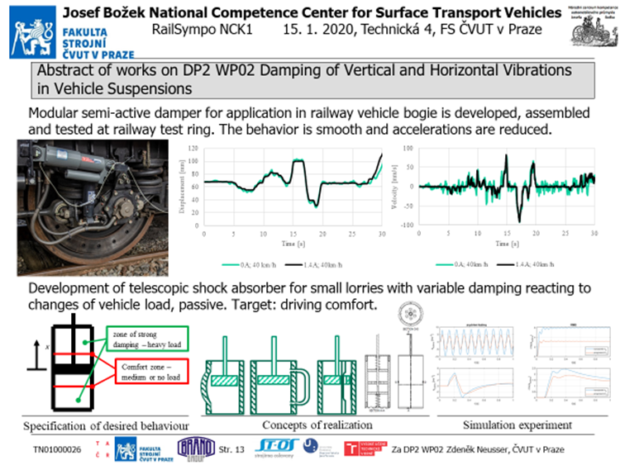
Figure 1 Summary of activities, results and deliverables of DP2 WP02

Workpackage Activities
In 2019 are developed two shock absorbers (dampers). First damper (outcome 2-WP02-002) is designed for railway application to stabilize and reduce railway bogie vibrations, the second one (outcome 2-WP02-004) is developed for small lorries to damp vibrations and could be also used as passenger cabin damper. The first damper is developed by Brno University of Technology with University of Pardubice and Strojirna Oslavany company. The second damper is developed by Czech Technical University in Prague with Brano company.
The working sample of the first damper (2-WP02-002) is finished and it has been tested at railway test ring. The damping behaviour is modified by magnetorheological fluid. Such fluid contains small particles which under influence of magnetic field changes its viscosity and corresponding damping. The coil itself is situated in the damper piston and magnetic field changes the properties especially of the fluid which goes through the piston channels.
At first the damper characteristics are measured without being installed on the bogie. The Figure 2 and Figure 3 shows dependency of the damper force in relation with damper displacement and displacement velocity for five settings of magnetic circuit of the magnetorheological damper.
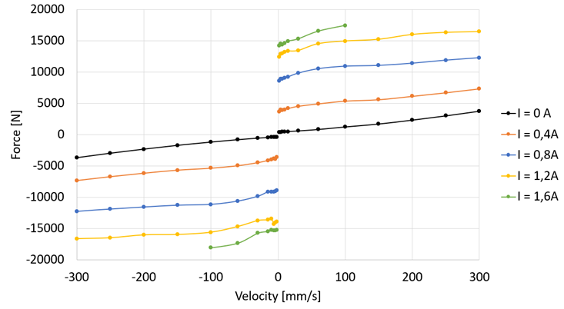  Figure 2 Measurement of damping force, force - velocity dependency (stroke ± 20mm). | 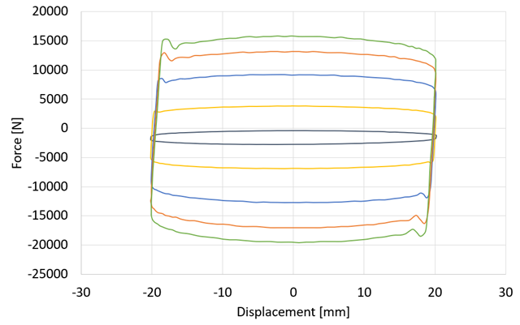  Figure 3 Measurement of damping force, force - displacement dependency (piston velocity ± 0,1 m/s).
Then follows the tests on the rail bogie of the locomotive, Figure 4. The influence of the damper settings to the resulting damper forces are displayed in the Figure 5 and Figure 6.
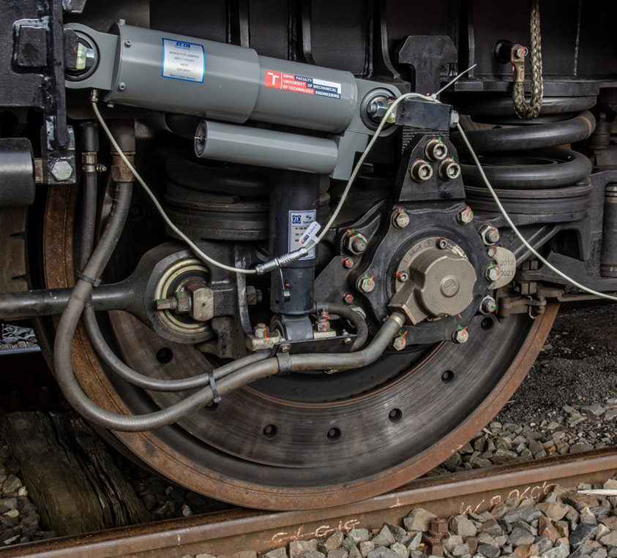
Figure 4 Damper position on the rail bogie during the tests.
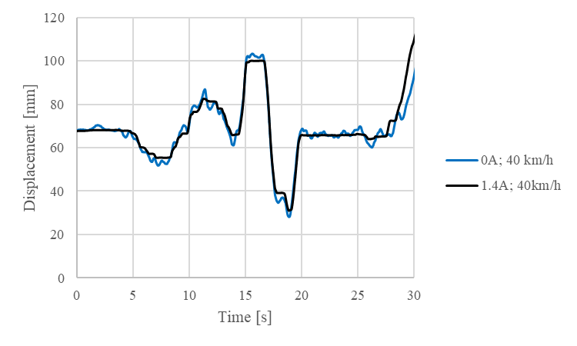  Figure 5 Measurement of the damper deformation in two cases for damper settings. | 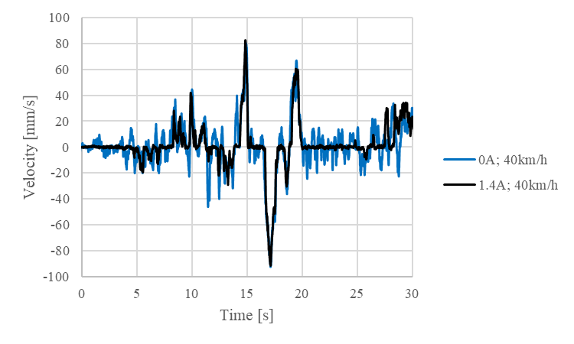  Figure 6 Measurement of the damper deformation velocity in two cases for damper settings.
The second damper (2-WP02-004) designed for car industry development starts with its specification. The damper should react to the vehicle load and corresponding damping forces influences the cabin acceleration which causes comfort or discomfort of the driver. There is defined ‘comfort zone’ for the driver, where the resulting acceleration should be minimal and zone with strong damping for high load forces, see Figure 7. The solution must be passive.
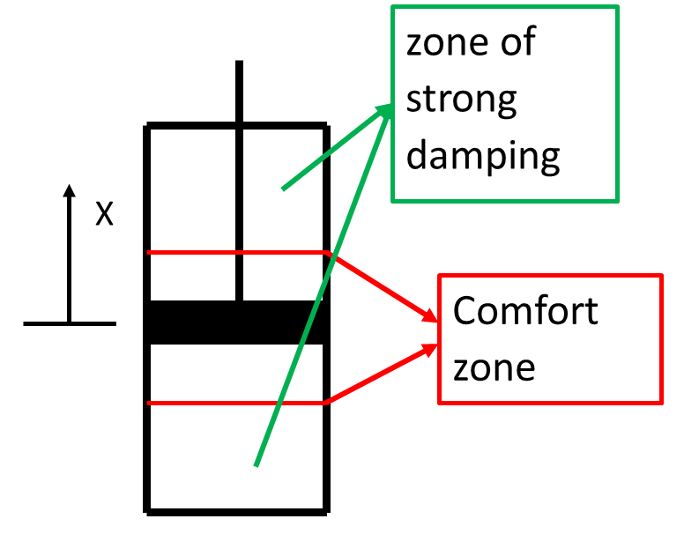
Figure 7 Desired behaviour specification.
Under such constraints there are found many ideas and shows some conceptual designs (Figure 8) of the damper with desired characteristics.
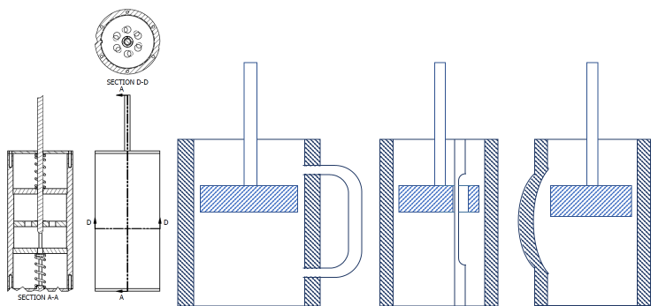
Figure 8 Four concepts of damper realisation.
The last variant in the Figure 8 is chosen for further investigations. It has easiest construction, the least expensive implementation, the lowest risk of defects in the damper operation. For this chosen variant is performed simulation experiment in the Figure 9. There are three columns, in the first one is displayed the road profile as an input, in the second row acceleration of the passenger cabin as an output and its root mean square value as a comfort indicator in the third row (less value, higher comfort). Red curves represent variant with the modified damper.
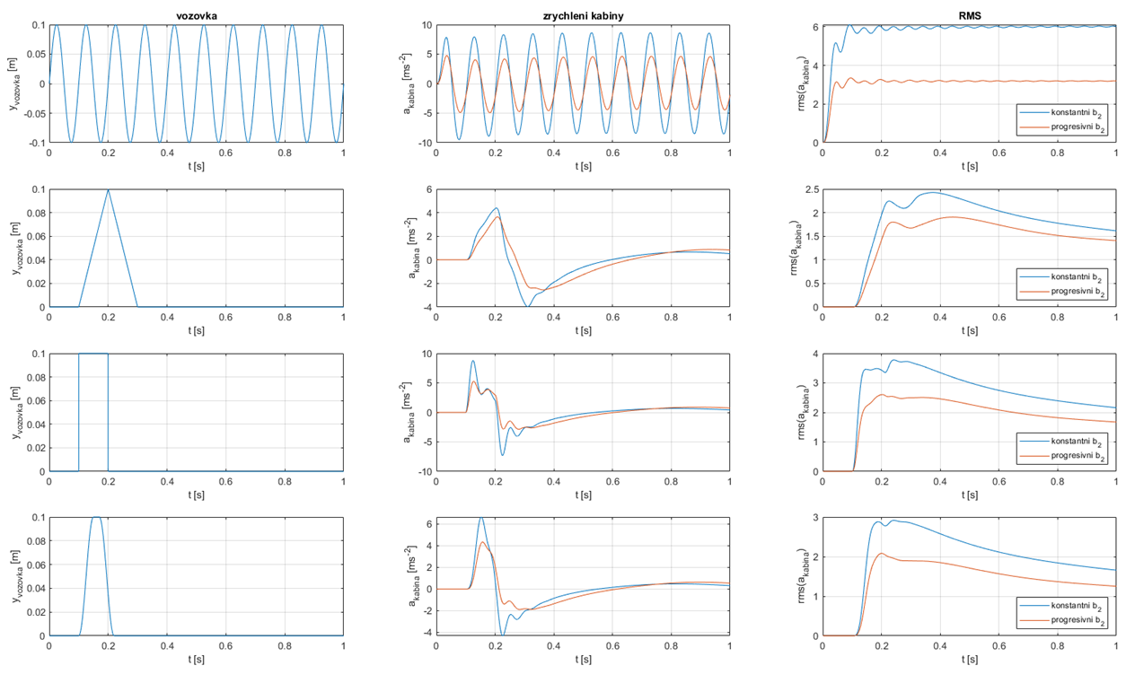
Figure 9 Simulation experiment.
All participants have several working team meetings during the first year period and there was also coordination meeting of whole 2-WP02 workpackage.

Workpackage WP02 Plan Fulfilment
Milestone 2-WP02-002: Modular semi-active damper for application in railway vehicle bogie. The output is finished, functional sample is finalized and fulfils the outcome deadline 12/2019.
Milestone 2-WP02-004: Telescopic shock absorber with variable damping reacting to changes of vehicle load. The development is according to the plan, output (functional sample) is planned to 12/2020.
Milestones 2-WP02-001, 2-WP02-003, 2-WP02-005 fulfils the plan.

Partial Goals
Milestone 2-WP02-001: Controller for semi-active damper. The progress corresponds the plan, output is planned to 06/2020.
Milestone 2-WP02-003: Simulation verification of the semi-active damping benefits in the bogie of electric locomotive. The works fulfils the plan, output is planned to 12/2020.
Milestone 2-WP02-005: Papers/conferences related to semi-active damping. The papers and presentations are continuously prepared, outcomes are fulfilled till 12/2020.

Currently Elaborated Project Deliverables and Milestones
Project milestones (2-WP02-001, 2-WP02-003, 2-WP02-004, 2-WP02-005) are elaborated according to the plan, milestone 2-WP02-002 is finished with resulting functional sample.
The milestone 2-WP02-002 Modular semi-active damper for application in railway vehicle bogie is finished and functional sample is assembled and tested. The 2-WP02-001 Controller for semi-active damper is under the development and is related with damper tests and measurements. Simulations for 2-WP02-003 Simulation verification of the semi-active damping benefits in the bogie of electric locomotive are realized in parallel with hardware development, the model is adjusted to be in acceptance with measurement. Publications in 2-WP02-005 Papers/conferences related to semi-active damping are planned and material is collected from the experiences from other milestones.
The damper 2-WP02-004 Telescopic shock absorber with variable damping reacting to changes of vehicle load development is in the conceptual and simulation verification phase. Selected concept (which is going to be realized as functional sample) is selected and simulation is performed.

Due Project Deliverables
The outcome TN01000026/2-V5 entitled 2-WP02-002 Modular semi-active damper for application in railway vehicle bogie is finished as a functional sample.

Contribution of Deliverable Application for Project Participants
Developed dampers are going to be in service railway and car producers participating on the project (e.g. Škoda). It helps to optimize driving properties of the related vehicle. The reduction of the accelerations to the vehicle body and to the road/track decreases their damage and failures during the transport. It increases the road persistence and reduces damage occurrence of the transported goods and increases passenger comfort.

Next Activities for WP02
Further activities are: the final design and realization of functional sample 2-WP02-004, other deliverables – controller for semi-active damper (2-WP02-001), simulation verification of the semi-active damping (2-WP02-003) and conference papers related to semi-active damping (2-WP02-005) are going to be utilized according to the project plan.

